**21CY681 - INTERNET PROTOCOL LAB - 9**

Name: Akhil K J

Register Number: CB.EN.P2CYS22009

Date: Dec 4, 2022

Assignment Topic: Simulating college netwrok connections using Packet Tracer

AB1 Block(ICTS Block)

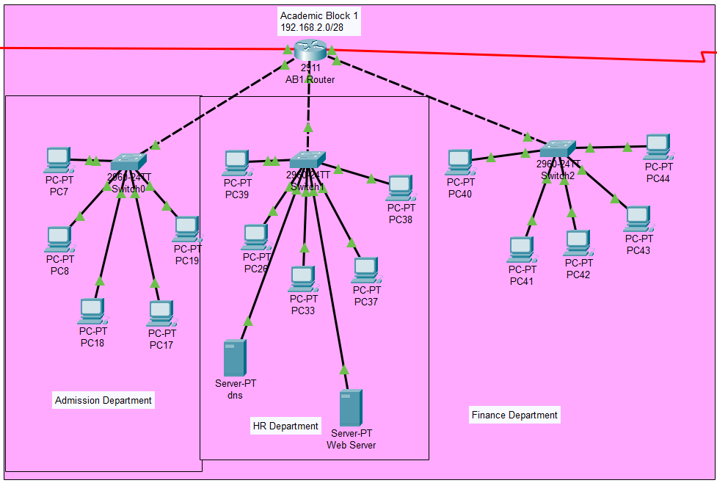

AB1 has 3 departments Admission, HR and Finance. The network provided is 192.168.2.0 and subnet provided is 255.255.255.240 through DHCP server. So, each department will have 16 range of IPs.

So, the IPs goes:

192.168.2.0-192.168.2.15

192.168.2.16-192.168.2.31

192.168.2.32-192.168.2.47

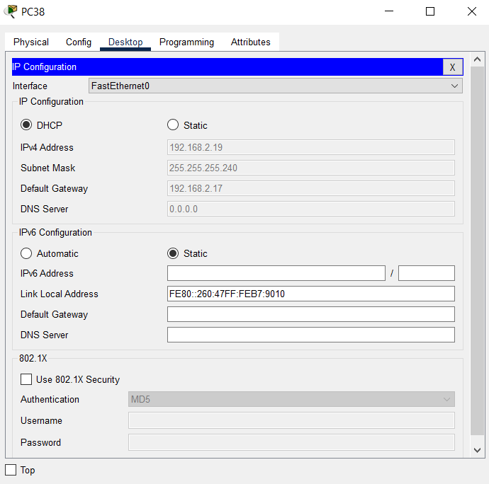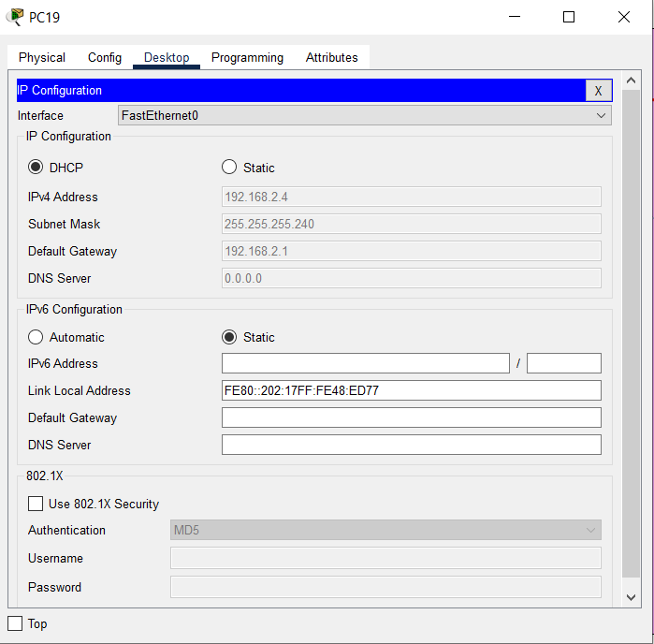

A DNS and Web server is connected which when a PC can get access to the web through web server’s IP.

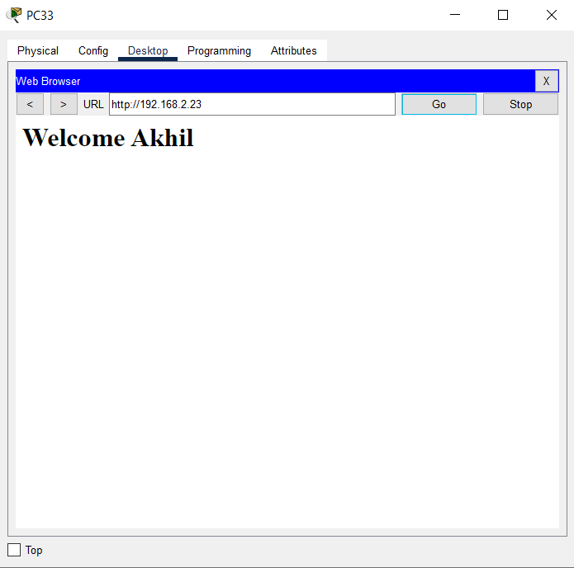

AB2 Block

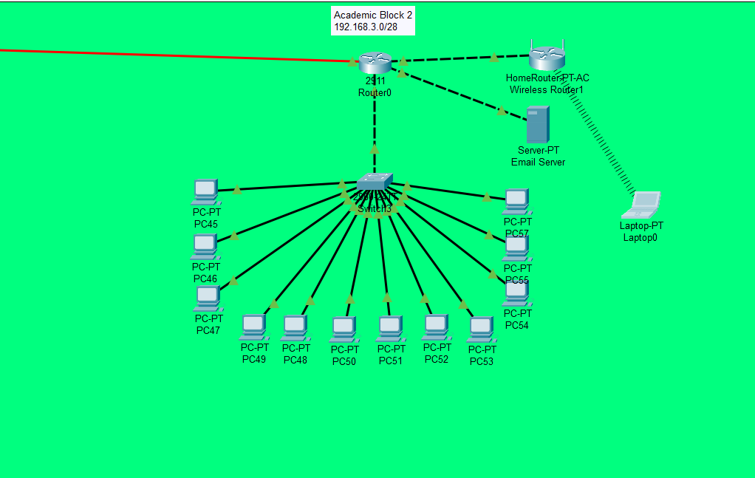

AB2 has 1 department and 12 PCs. This network is given 192.168.3.0 and 255.255.255.240 and given as static.

IP ranger from:

192.168.3.0-192.168.3.15

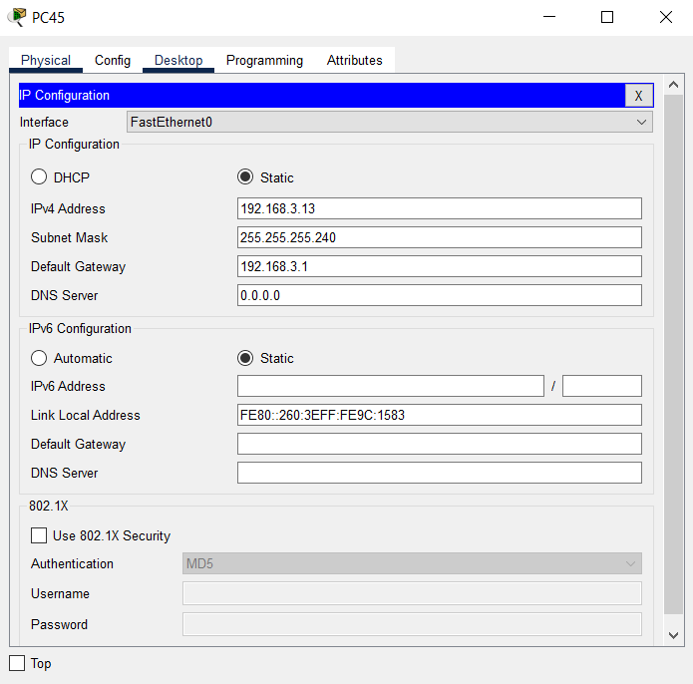

A Email Server is connected to it and a wireless router is connected to the router as a wifi module.

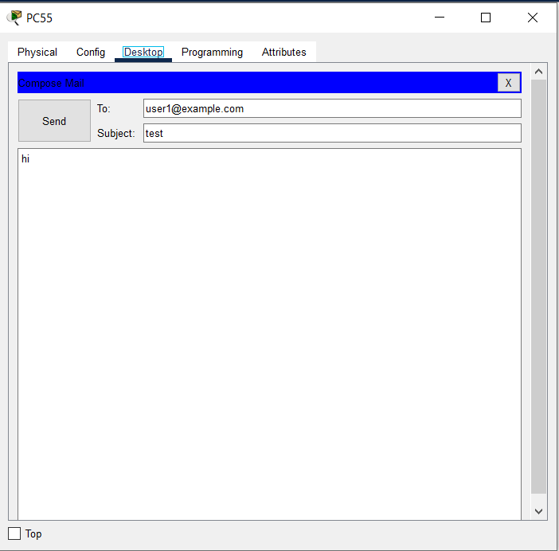

AB3 Block

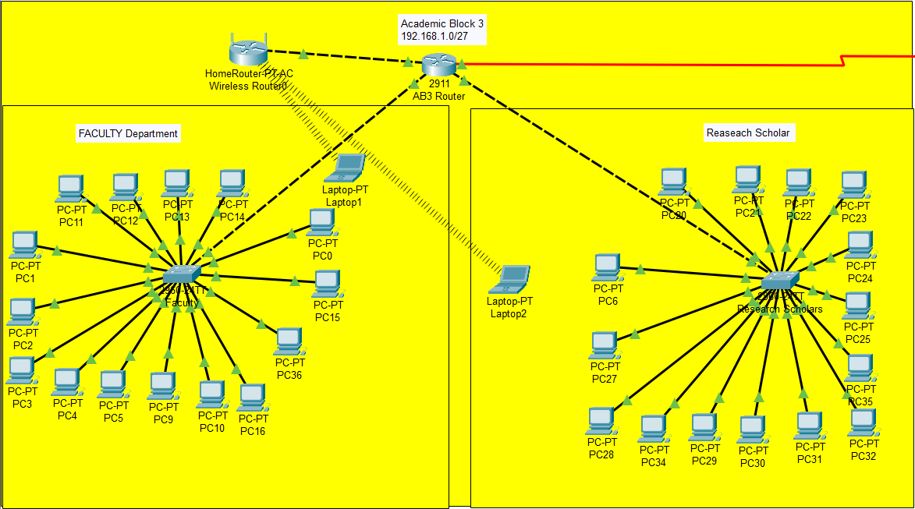

In this Router is connected to 2 different departments: Faculty and Research Scholar Department.

Network is 192.168.1.0 and subnet is 255.255.255.224 connected through DHCP.

IP ranges from:

192.168.1.0-192.168.1.31

192.168.1.32-192.168.1.63

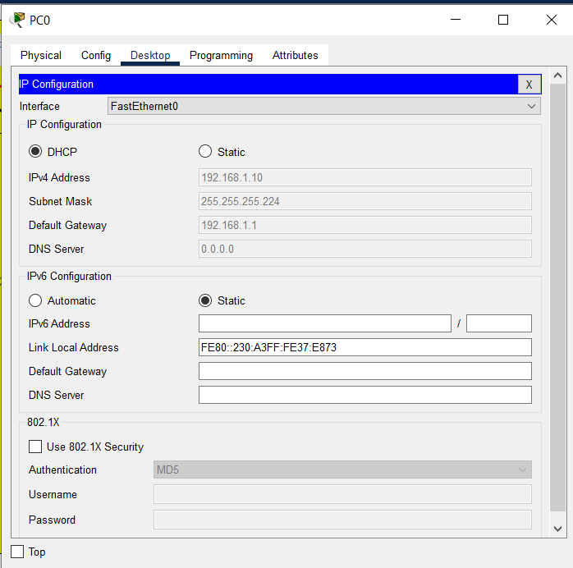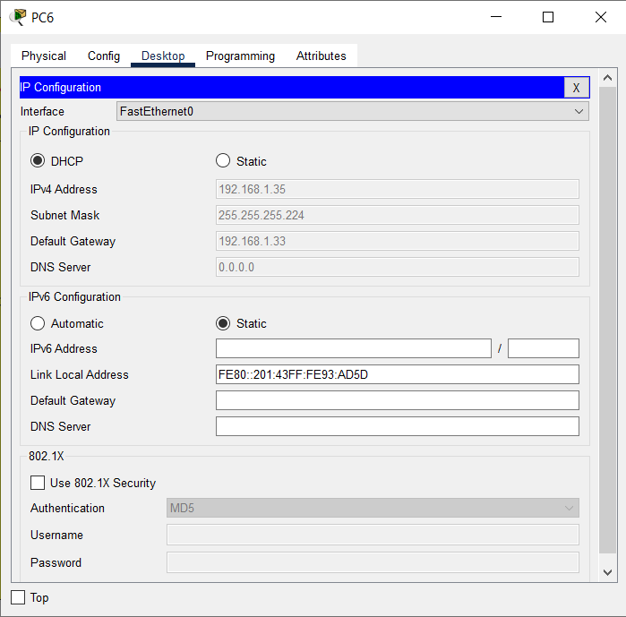

A homeless router is connected as wireless router. Two laptops are connected to the wireless router.

3 networks are connected through static routing.